A Starter Manuscript Built with document-sanity
First Author (1); Second Author (1,2)
[1] Department of Research, Example University
[2] Department of Collaboration, Partner Institute

Abstract
We analyzed 1,247 samples and found a significant effect (p = 8.70e-03, R² = 0.87). This abstract demonstrates the {{VARIABLE}} token substitution syntax; see the sections for more examples.
Keywords: example, template, markdown, document-sanity

Introduction
Welcome to the document-sanity starter template. This paragraph demonstrates bold, italic, inline code, and inline math: E = mc^2.
Variable substitution happens at build time — we have 1,247 samples in total, achieving an overall R² of 0.87 (p = 8.70e-03). In the HTML viewer, clicking those values pops up their provenance (source files, command, updated date) because the manifest declares a provenance: block for them.
Cite with [1] — the HTML viewer will number it and link to the rendered <li> in the references section: [2].
Cross-reference with ... — see Figure 1 for the framework overview, and the method details in Section 2.

Background
Lists work as you'd expect:
- First bullet item.
- Second item with formatted text and a link.
- Third item with a reference to [3].

Numbered steps
- Install document-sanity (see README).
- Edit this file or add new sections.
- Run make html to preview, make pdf to export.

Methods
Methods are written in plain markdown with LaTeX pass-through for anything complex — figures, tables, multi-line equations.

Math
Inline math like \text{Pr}(x \mid \theta) uses the \prob macro defined in templates/article.tex. The document-sanity preview command auto-expands such macros inside math when it emits the markdown-preview blocks, so GitHub's KaTeX renders them too.
Display math:
\log \frac{y_i}{1 - y_i} = \sum_j X_{ij} \beta_j + \alpha_i + \log \frac{\pi}{1 - \pi}
Or, for fuller control, wrap in a `latex block:
\Pr(d \mid \mathcal{D}) = \frac{\Pr(\mathcal{D} \mid d)\,\Pr(d)}{\Pr(\mathcal{D})}
Reference it with Equation 1.

Figures
Reference manifest-declared figures with \includegraphics[width=\textwidth]{figures/example.png}:
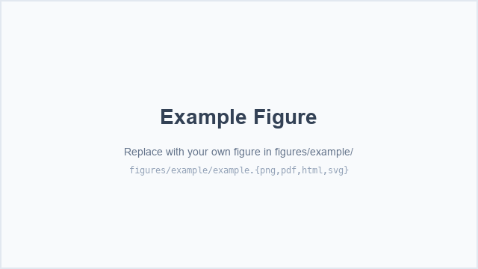
Figure 1: Framework overview. Replace this image with your own by dropping a file into \texttt{src/VERSION/figures/example/example.png} (or .pdf, .html, .svg).

Or, for figures you won't reference from other places, inline an image:
![Example caption.](../figures/example/example.png)
See docs/figures.md for the full figure layout conventions.

Tables
Simple tables — write them in native markdown:
Condition | N | Mean ± SD
Control | 420 | 1.24 ± 0.18
Treatment | 827 | 1.51 ± 0.22

The builder converts these to \begin{tabular} for LaTeX and <table class="md-table"> for HTML.
Complex tables (multi-column headers, \cmidrule, subtables) belong in a fenced LaTeX block:
(table — Example complex table.)
Reference the table above: Table 1.

Results
Put your findings here. Lean on variable substitution — if every number in the paper comes from manifest.yaml, you update values in one place and everything else stays consistent.

Primary analysis
Our primary test rejected the null with p = 8.70e-03 across 1,247 samples (see Methods, Section 2).
The effect was consistent across subgroups (Table 1). As shown in Figure 1, the framework captures the relationship we expected.

Inline-markdown table
Use a plain markdown pipe table when the values won't change between edits — captions, summary descriptors, presentation-only tables.
Metric | Value | Notes
Sample size | 1,247 | Total enrolled
R² | 0.87 | Primary regression
p-value | 8.70e-03 | Two-sided, BH-adj

Data-driven table from `tables/subgroup_summary.csv`
Use a separate data file when the table is generated by an analysis script. Declare it in manifest.yaml under tables:, then reference with a XXXX token. The token expands to a markdown pipe table at build time so PDF, HTML, and Word all render identically:
Subgroup | N | Mean | SD | p
Overall | 1247 | 1.24 | 0.18 | 0.0087
Female | 612 | 1.21 | 0.17 | 0.012
Male | 635 | 1.27 | 0.19 | 0.014
Age < 50 | 521 | 1.19 | 0.16 | 0.018
Age >= 50 | 726 | 1.28 | 0.20 | 0.0091

Re-run your analysis, overwrite the CSV, rebuild — every output stays in sync.

Robustness
Follow-up analyses corroborated the primary finding. Replace this paragraph with your own, or add subsections as needed.

Discussion
Summarize the main finding in the first sentence. Use the rest of the paragraph to contextualize against prior work [2, 3].

Limitations
List the main caveats here. Writing them as markdown bullets keeps them easy to rearrange:
- Limitation one — explain briefly.
- Limitation two.
- Limitation three.

Conclusion
End with a one-paragraph conclusion. Cite the specific contributions made by this paper rather than re-summarizing the results.

References
[1] key — MISSING
[2] Alice Example, Bob Colleague. An Example Paper about Things. Journal of Example Research 42(3), 123–145 (2024). https://doi.org/10.1234/example.2024.001
[3] Carol Other, Dave Researcher, Erin Team. Another Study with Important Findings. Nature Example Science 7, e12345 (2023). https://doi.org/10.1038/example.2023.002

